INTENDED USE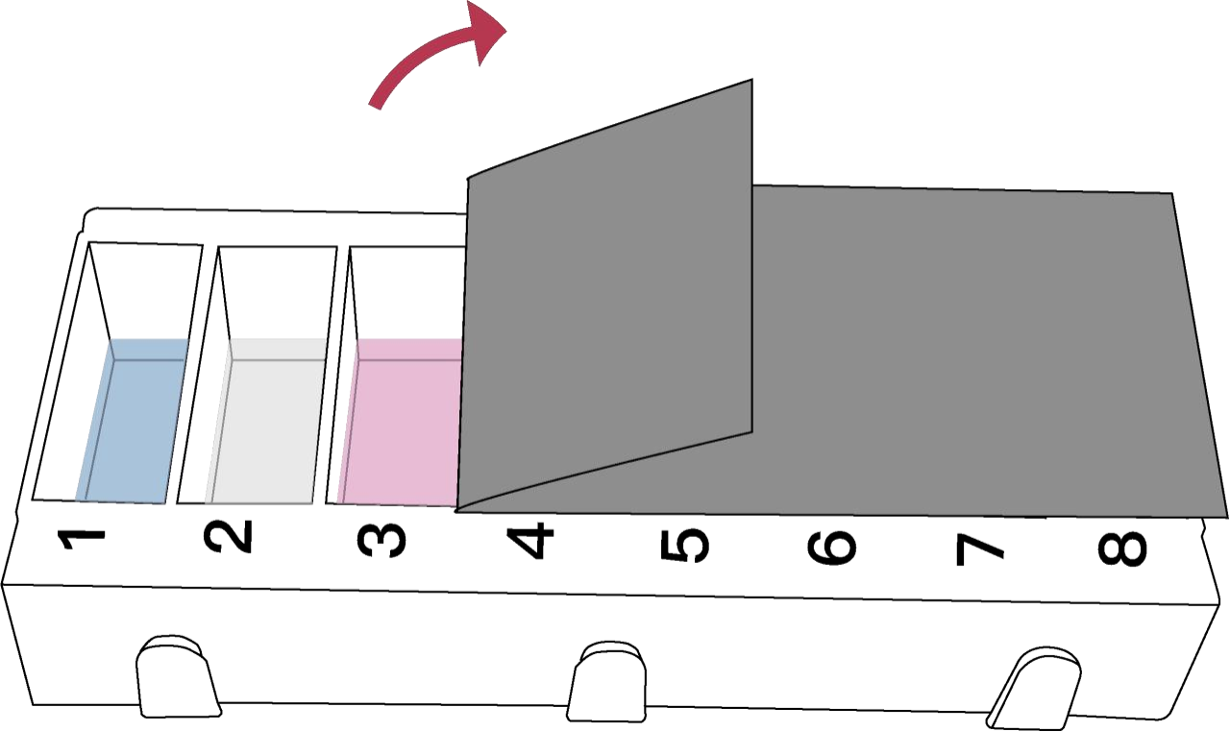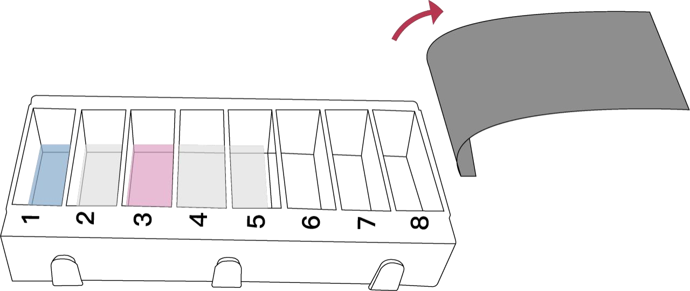

CANINE T&S IgE TEST KIT is designed to determine the levels of Total

IgE (T IgE) and Specific IgE (S IgE) in canine serum.

KIT CONTENTS

aluminumfoilbagwithadesiccant.TheSolutionUnitcontainsallthe

necessary reagents for forming enzyme linked complex of

antibody-antigen reaction that are deposited separately in the

different compartments of a plastic cartridge and sealed with a

will be labeled with enzyme in the compartment 3, which contains

anti-canine IgE- enzyme conjugate.

Forasatisfactoryresult,washstepsareintroduced.Inthecompartment

2,theunboundcanineIgEantibodiesandothersubstancesintheserum

interpretation can be recorded by hand in the Result Card provided

according to the INTERPRETING TEST RESULTS.

TEST PROCEDURE

Preparation before performing the test:

Performing the test:

1. Hold tightly the solution cartridge with one hand and pull the

protective foilalongthehorizontaldirectioncarefully withanother

hand from the compartment 1 to 8 to remove whole the protective foil

CANINE T&S IgE TEST KIT (T+74S)

INSTRUCTION MANUAL



Contents

Solid Array Unit

Solution Unit

Substrate

Result Card

Quantity

2

2

2

2

protective aluminum foil. The Substrate is deposited in a small

substrate bottle.

Briefly, pull open the Solution Unit and deposit the serum sample in

the compartment 1 of the Solution Unit and mix well. After tearing

aluminum foil bag, take the Solid Array Unit out and pull off the

sample will be removed. In compartment 4 and 5, the unbound or excess

enzyme conjugate will be adequately removed.

Attheend,pipettesubstrateinthesubstratebottle,andslowlydrop

the substrate on the membrane at the window center to develop

purple-blue spots if there were enzyme bound there.

1. Bring one Solid Array Unit, one Solution Unit and one Substrate to

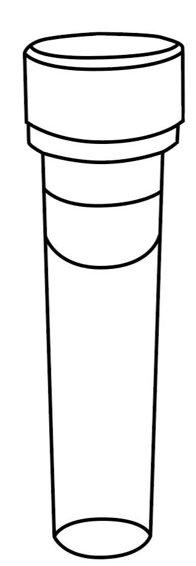room temperature (20℃-30℃) for 30 minutes before using.

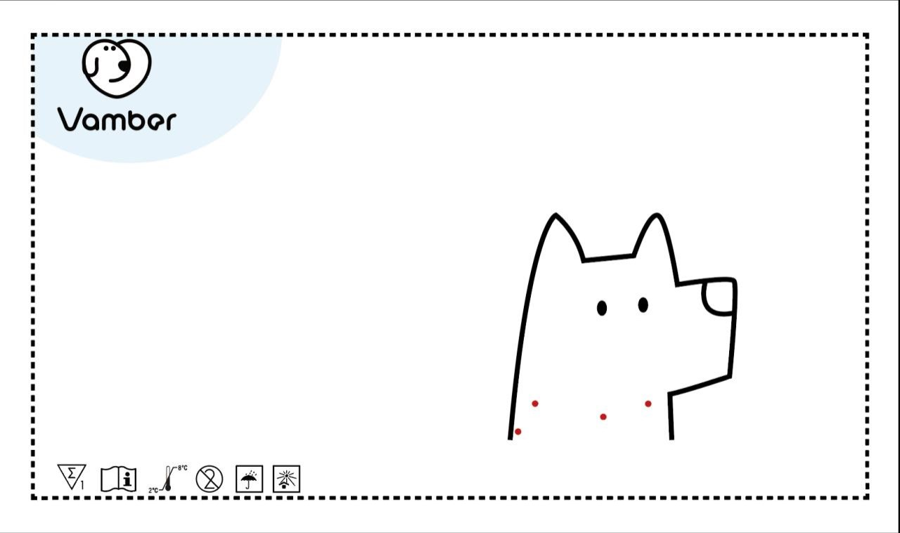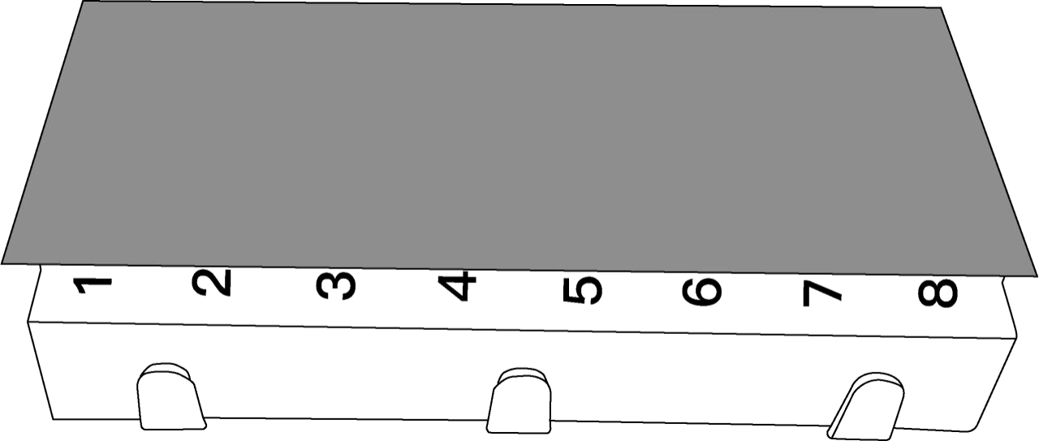

off.

2.Obtain150μLofthetestedserumsamplewithaproperdispenserset

Locator 1 protectivecap.Immobilizedlocationmarkers,anti-canineIgEantibody, Toconfirmthevalidationoftheperformance,purple-bluecolorofthe 30min 20-30°C with a pipette tip.

Color Scale 1

Instruction Manual 1

Pet Label 2

DESIGN AND PRINCIPLE

and allergenic substances can be observed as pink spot array on the

membraneinthewindowoftheSolidArrayUnit. TheninserttheSolid

Array Unit into the compartment 1 and have it absorb the solution in

thecompartment1forafewminutes.Aftertheabsorption,thepinkdye

locationmarkersonthemembraneshouldbevisibleaboveacertainlevel

after finishing a successful testing process.

Thelocationmarkerswillbealwaysvisibleonthemembraneinthewindow

of the Solid Array Unit after successful testing.By putting the

2.Prepareadispenserandtwopipettetipsproperfor150μLand1000μL.

3. Stand upright the Solution Unit on a work bench and confirm that

compartmentnumbers,from1to8,canbeseenincorrectdirection.Stamp

the Solution Unit slightly to make sure the solutions in the

3. Deposit the sample into the compartment 1. Then raise and lower

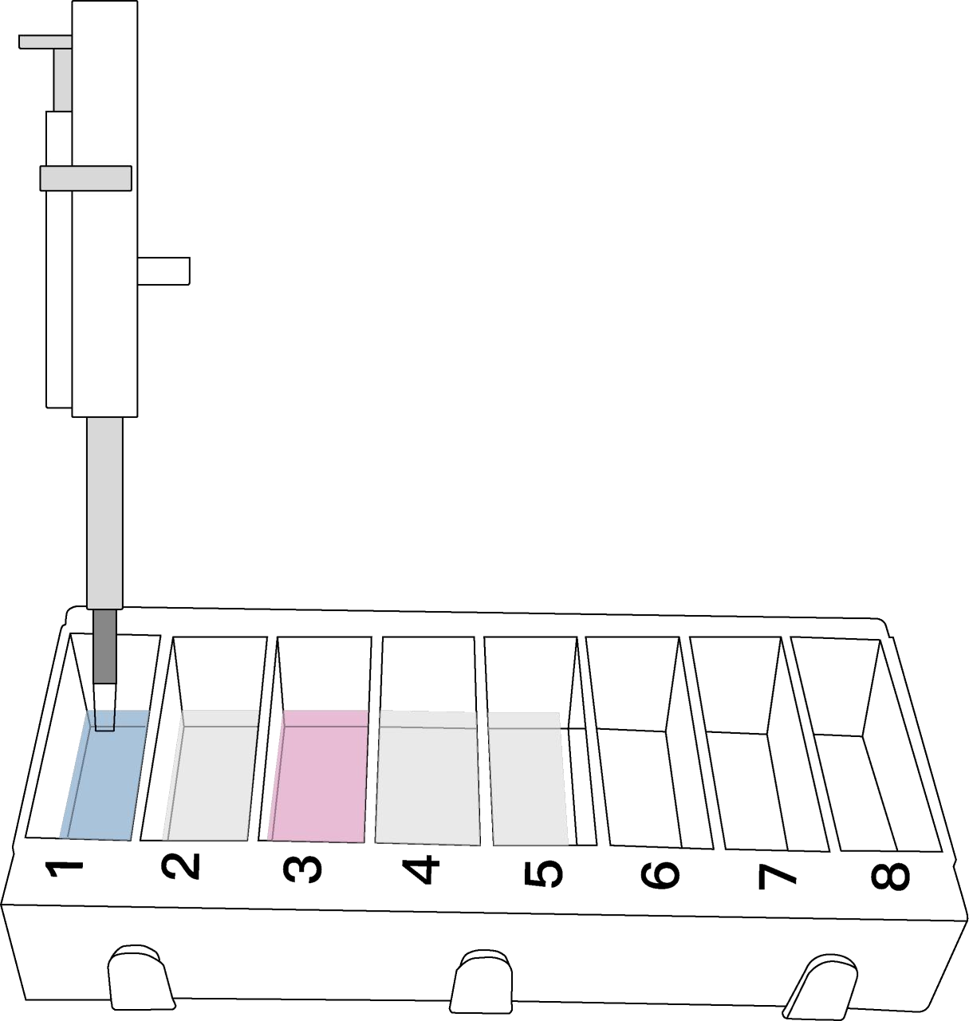dispenser plunger several times to achieve mixing

Foronesampletesting,oneSolidArrayUnit,oneSolutionUnitandone

Substrateshouldbeusedtogether.TheSolidArrayUnit,whichcontains

immobilizedlocationmarkers,anti-canineIgEantibody,andallergenic

substances on a membrane and a protective cap, is packaged in one

will disappear from the membrane in the window, which indicates

successfulspecificantibody-antigenreactionfinished.ThentheSolid

Array Unit will be transferred to the remaining compartments at timed

intervalsstepbystep.TheboundcanineIgEantibodiesonthespotarray

transparent Locator on the window of the Solid Array Unit in correct compartments, from 1 to 5, turn back to the bottom.

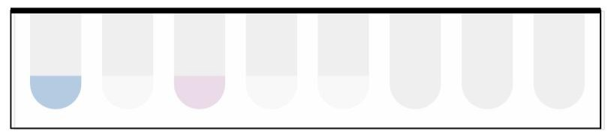position, the Total IgE and Specific IgE spots can be located.

BycomparingthevisiblespotswiththeColorScaleprovided,thesignal

strength can be obtained and the levels representing the clinical .

4.TearthealuminumfoilbagandtaketheSolidArrayUnitout,followed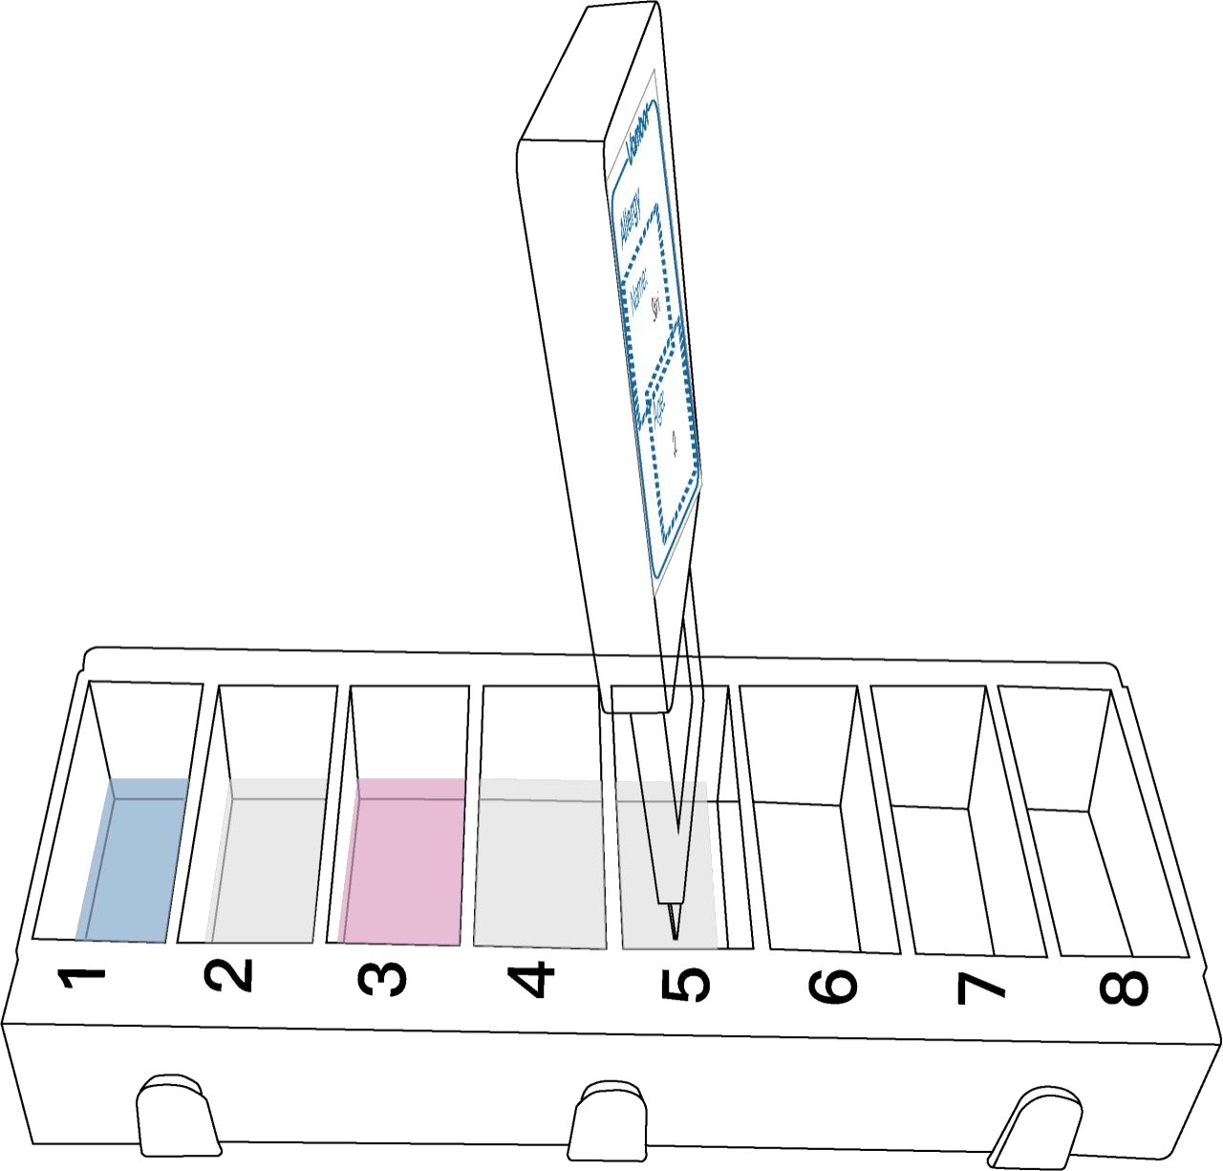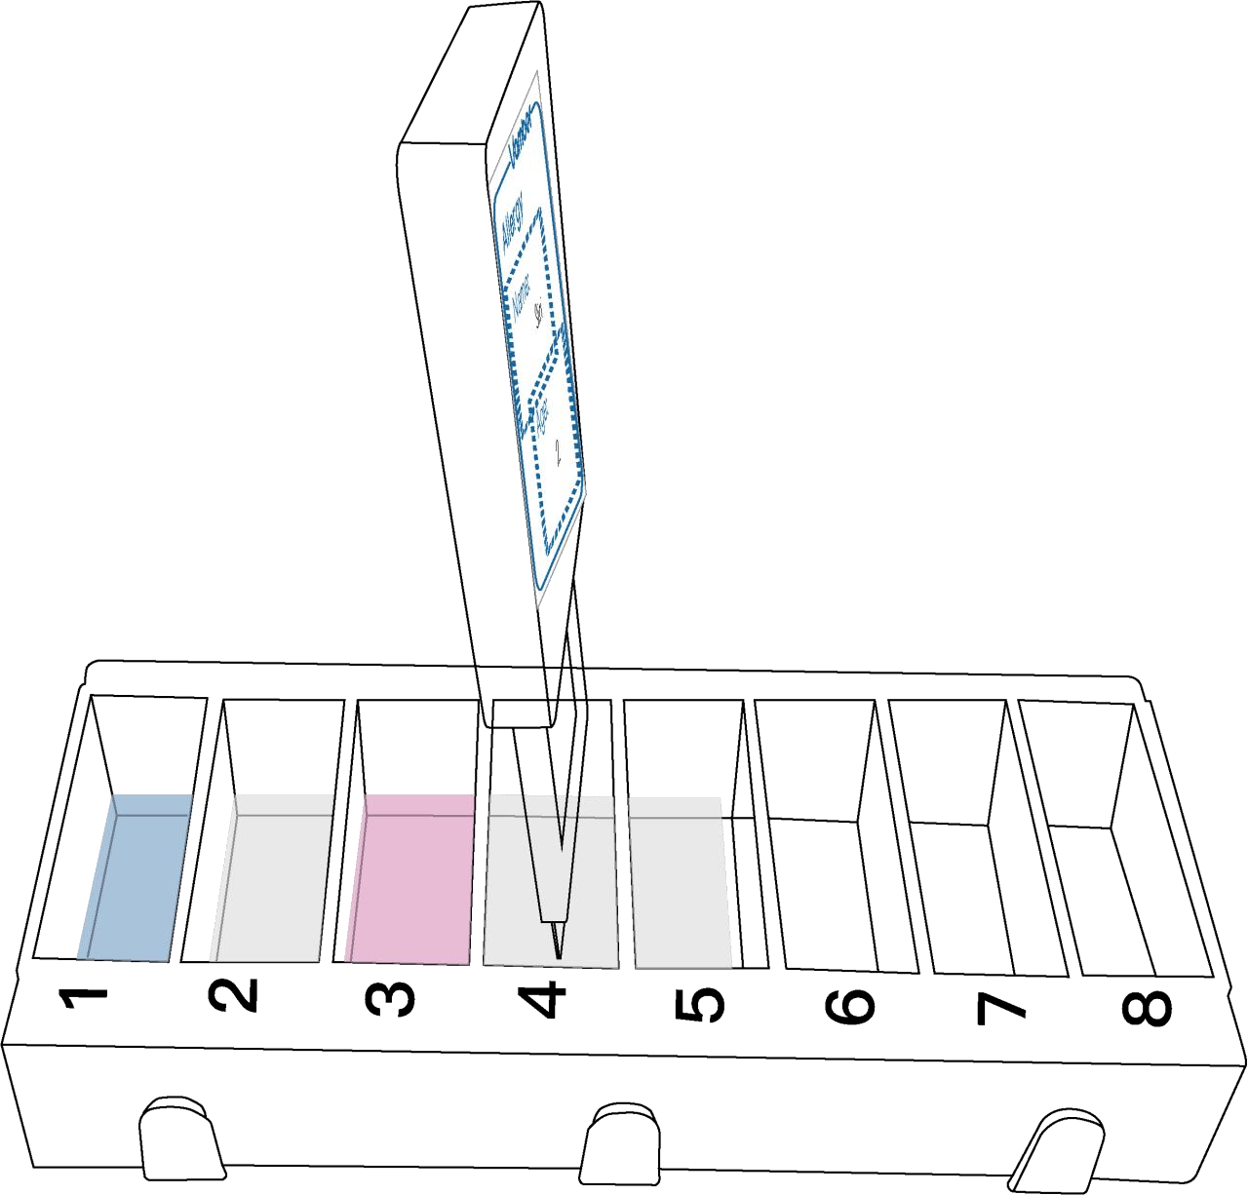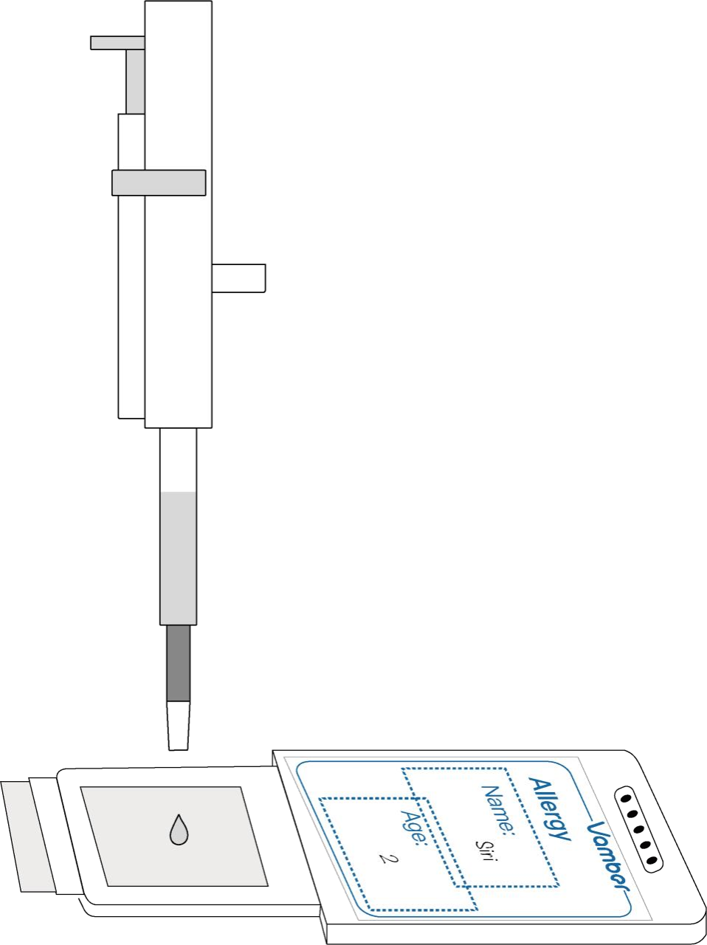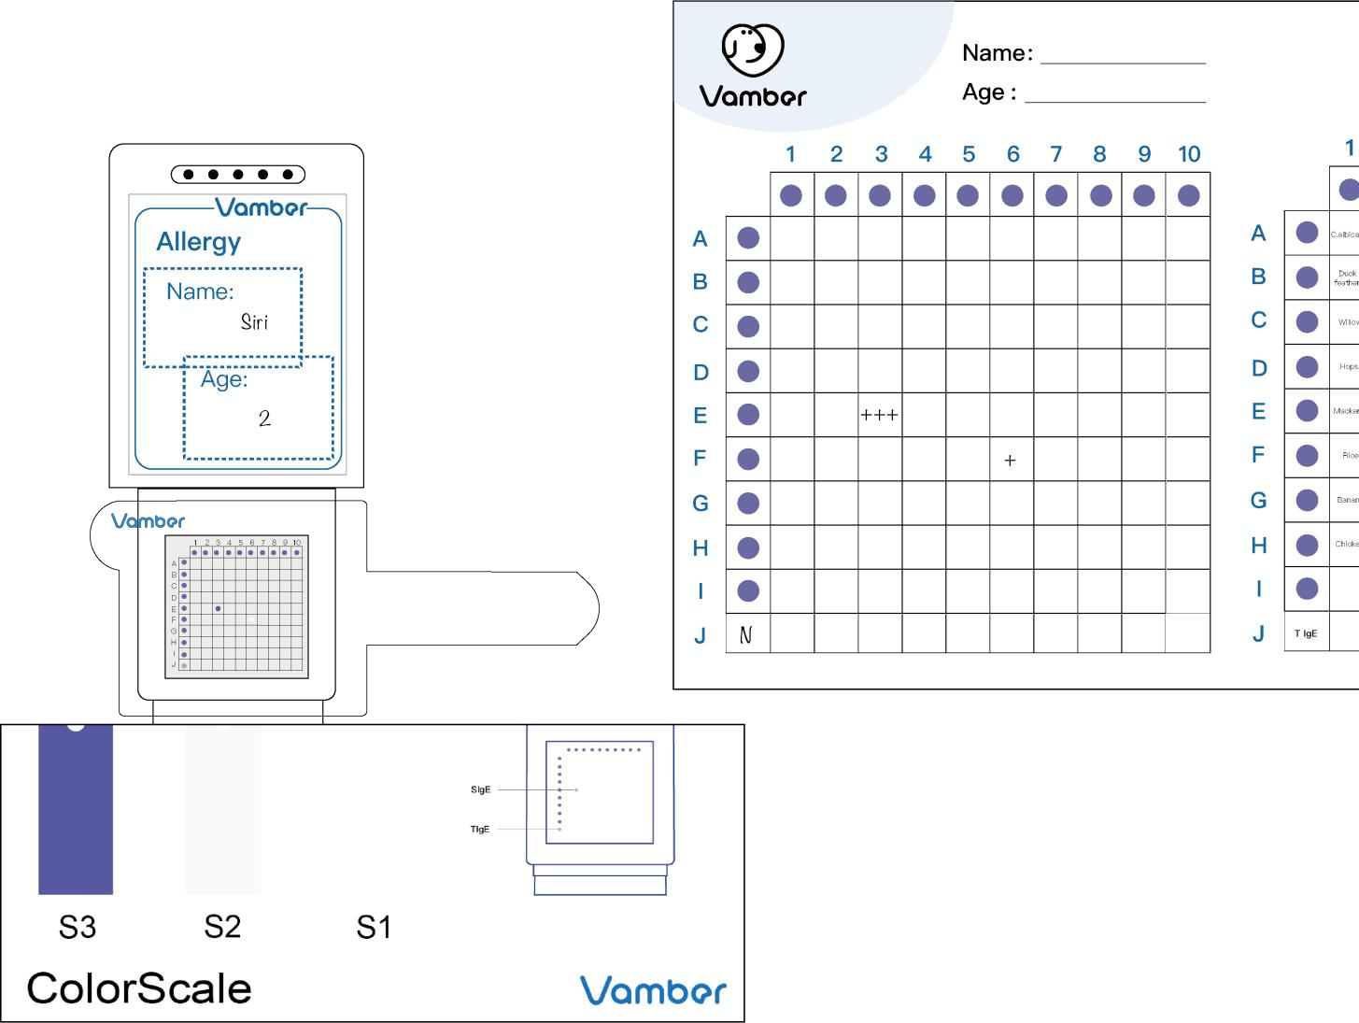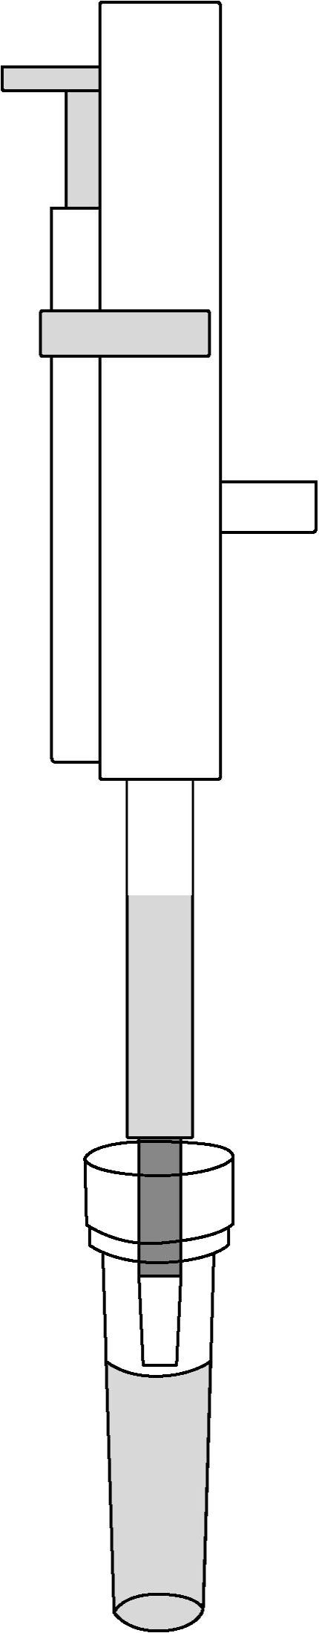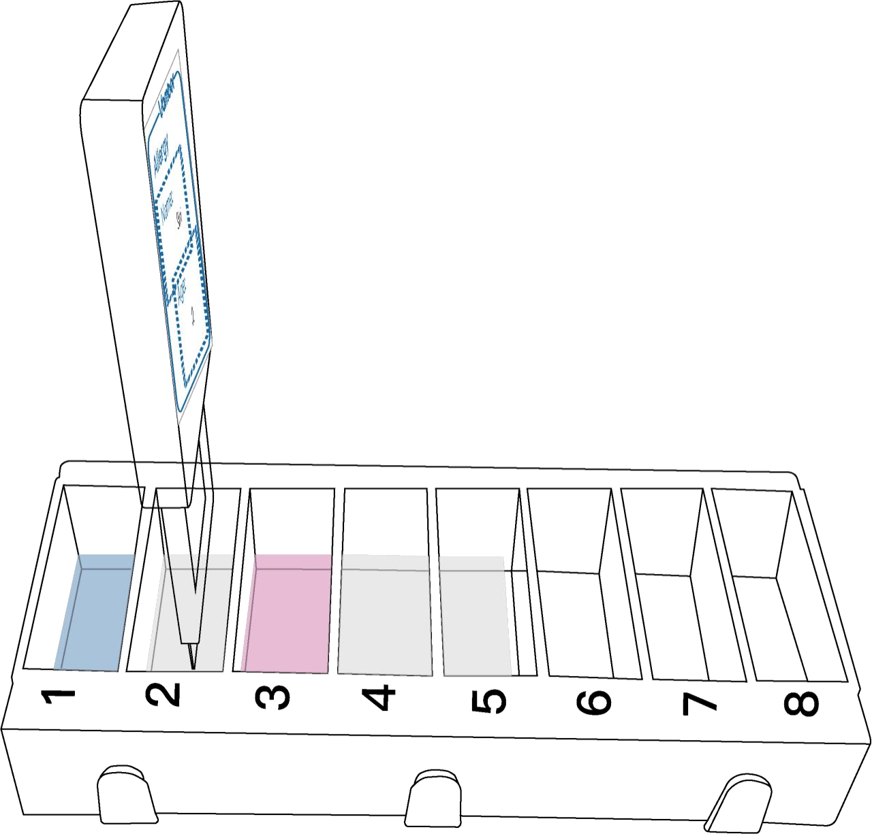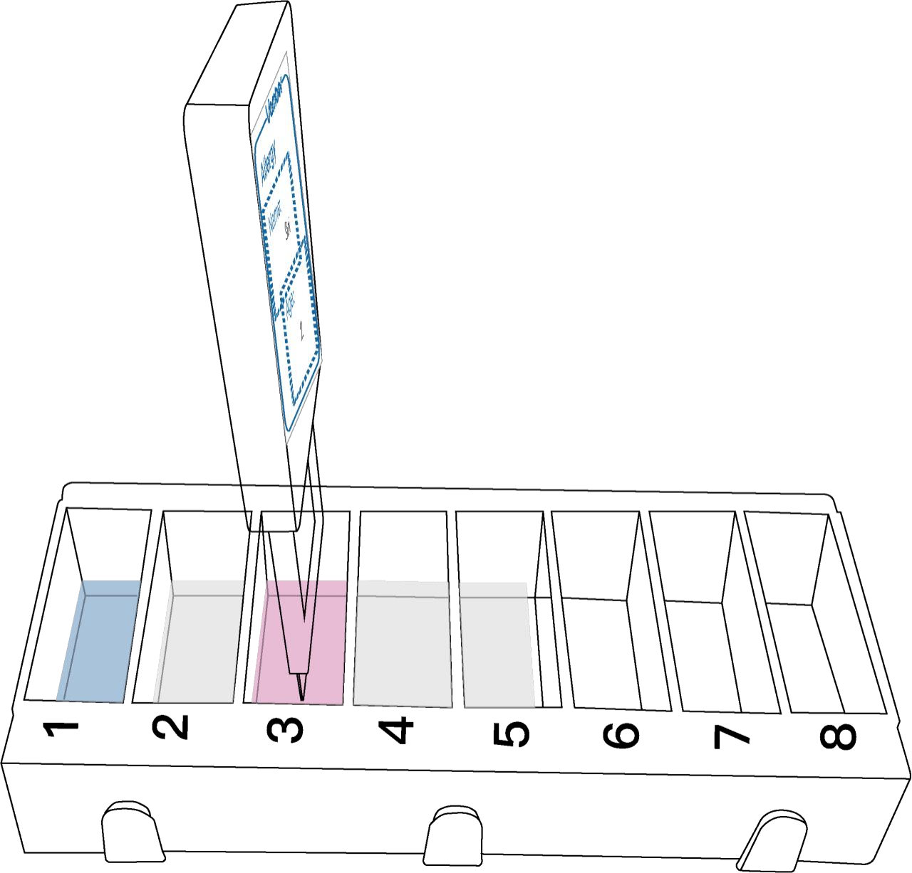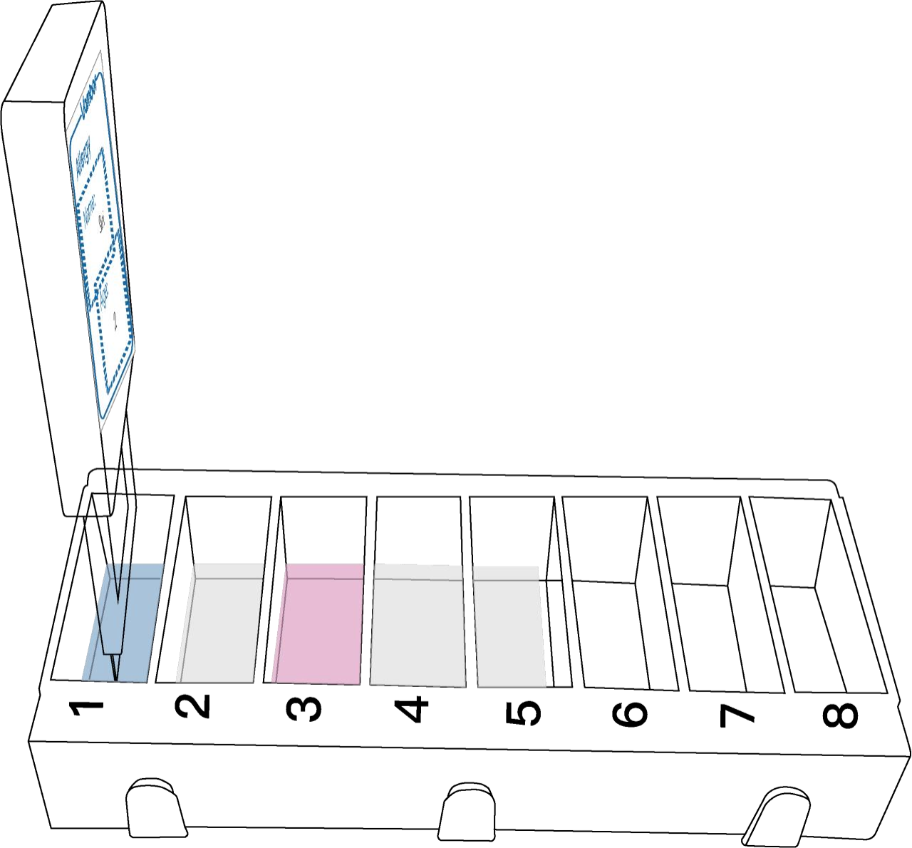

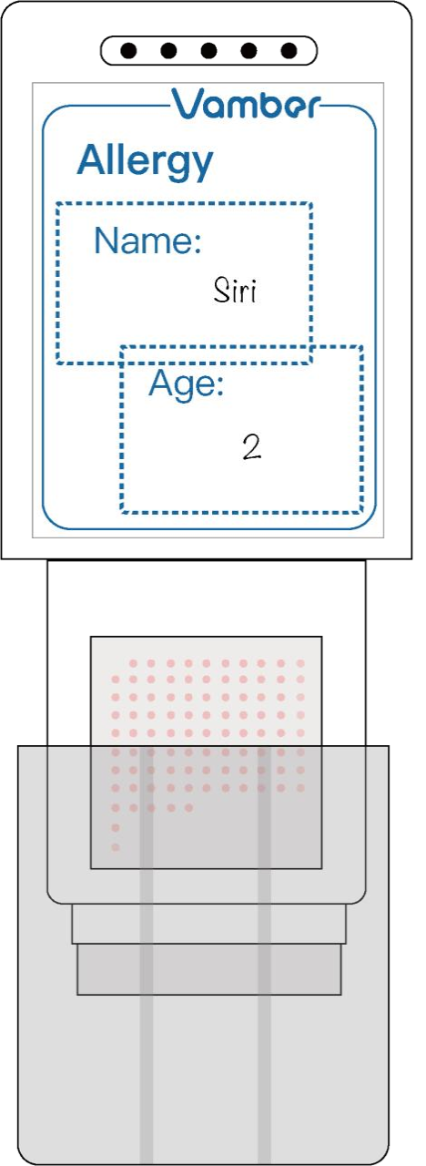by pulling the protective cap off.

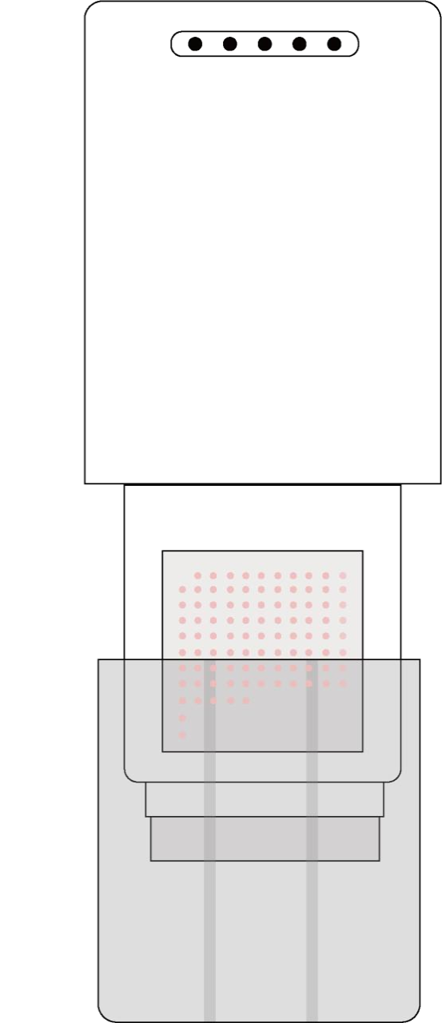

If necessary, attach the provided Pet Labels for more than one sample

testing.

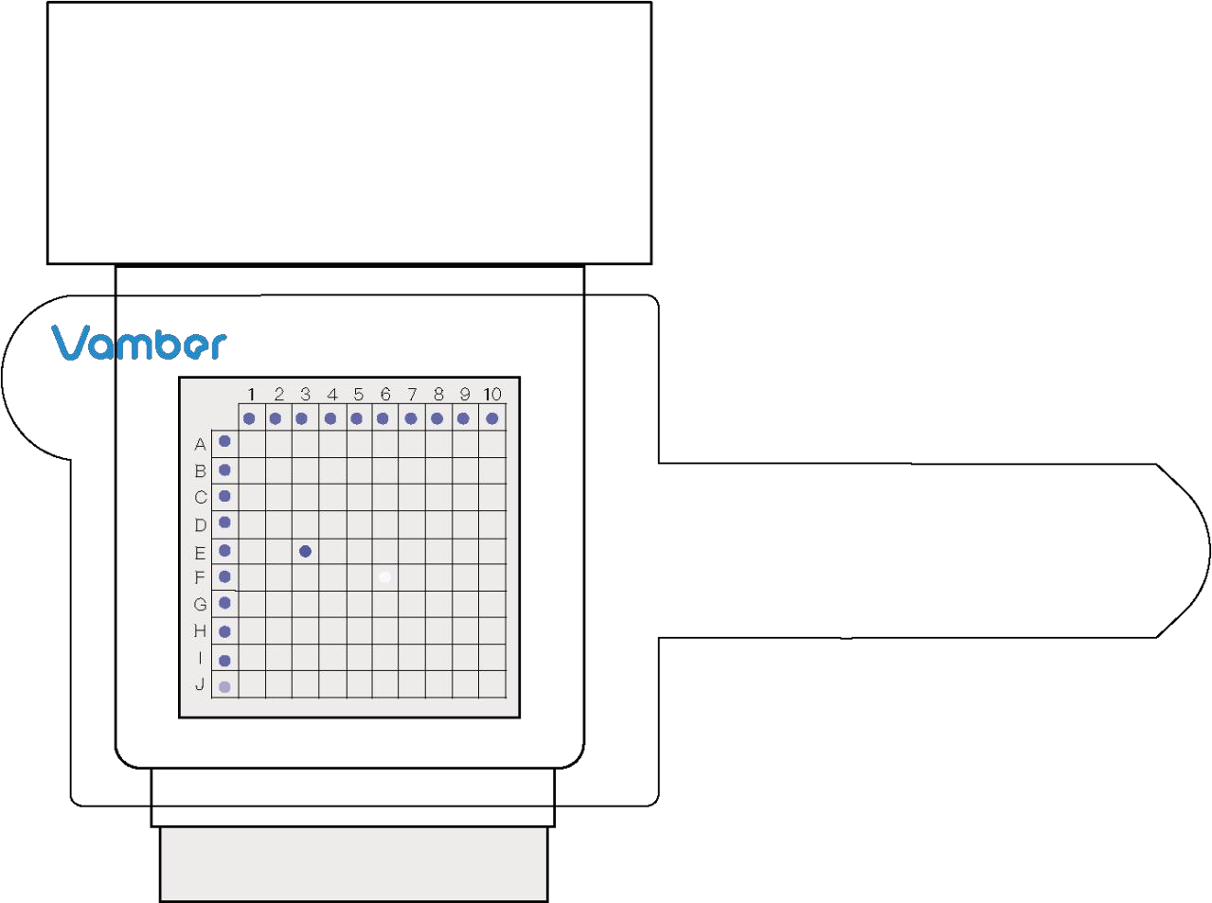INTERPRETING TEST RESULTS

ThespotrepresentingTotalIgElevelinserumsampleislocatedonthe

far left and bottom.

Specific IgE

Comparing with provided Color Scale, there are four conditions

illustrated as the following table.

5. Insert the Solid Array Unit into the compartment 1 for 7 minutes.

6. Pick up the Solid Array Unit and insert it into the compartment 2

for 7 minutes.

7. Pick up the Solid Array Unit and insert it into the compartment 3

10. Pick up the Solid Array Unit and lay it flat on a work bench.

11. Pipette 500μL of Substrate from the substrate bottle, and add the

Substrate drop by drop on the membrane at window center.

13.Put the Locator on the window of the Solid Array Unit in a proper

position,andfind the corresponding positionin the spot array (PISA)

of the Total IgE and Specific IgE spots if visible.

14.ComparethevisiblespotswiththeColorScaleprovidedtodetermine

Notes:

UsetheSolidArrayUnitassoonaspossiblewhentakingtheprotective

Interpretation

Normal

Weak positive level

Positive level

High positive level

For Specific IgE

level

Test spot≤S1

S1＜Test spot≤S2

S2＜Test spot≤S3

S3＜Test spot

Notation

-

+

++

+++

for 7 minutes.

8. Pick up the Solid Array Unit and insert it into the compartment 4

for 7 minutes.

12.Waitfor10minutesfordevelopingpurplebluecolorspotsandrecord

the result notation with 5 minutes..

the corresponding signal strength level.

15.RecordthenotationofthelocatedvisiblespotsrepresentingTotal

IgEand SpecificIgEin theResultCardprovidedbyhanddaccordingto

cap off.

Donottouchthemembraneandthepinkspotsimmobilizedonthemembrane.

Hold the cartridge of the Solution Unit tightly when pulling, along

Total IgE

Comparing with provided Color Scale, there are three conditions

illustrated as the following table.

Theallergenicsubstancesthatmayraisethelevelofthecorresponding

specificIgEandtheirpositioninthespotarray(PISA)are listedin

the following allergenic substance list.

9. Pick up the Solid Array Unit and insert it into the compartment 5 the illustration in the INTERPRETING TEST RESULTS tables. horizontal direction, the protective foil off. Interpretation For Total IgE level Notation PISA Allergenic substances

for 7 minutes. Use different clean tips for transferring sample and Substrate.

Interpret results after finishing testing process within 5 minutes.

Abnormally low

Normal

Abnormally High

Test spot≤S2 AL

S2＜Test spot≤S3 N

S3＜Test spot AH

A 1 Candida albicans

A 2 Penicillium

A 3 Aspergillus fumigatus B 10 Goosefoot

A 4 Alternaria alternata

D 5 Cockroach

D 6 Clam

E 10 peanut

F 1 Rice

G 5 Duck

G 6 Cheese

provided with this kit; however, it is recommended that positive and

negativecontrolsbeinvolvedasagoodlaboratorypracticetoconfirm

A 5 Cladosporium herbarum PISA Allergenic substances D 7 Salmon F 2 Wheat G 7 Beef the test procedure and to verify proper testing performance.

A 6 dermatophagoides farinae

A 7 Tyrophagus putrescentiae

A 8 Dermatophagoides pteronyssinus

A 9 Blomia tropicalis

C 1 Willow

C 2 Pine

C 3 Bermuda grass

C 4 Birch

D 8 Sardine

D 9 Tuna

D 10 Anchovy

F 3 Corn

F 4 Kiwi

F 5 Potato

F 6 Orange

G 8 Mutton

G 9 Egg, whole

G 10 Cow‘s milk

H 1 Chicken

STORAGE

1. Store the kit under normal refrigeration (2~8℃).

DO NOT FREEZE THE KIT.

2. The kit contains inactivated biological material. The kit must be

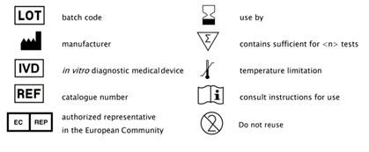A 10 Cow dander C 5 Elm PISA Allergenic substances F 7 Pear H 2 Pork handledanddisposedofinaccordancewithlocalsanitaryrequirements.

B 1 Duck feathers

B 2 Cat dander

C 6 Mulberry

C 7 Mulberry, Paper

E 1 Mackerel

E 2 Crab

F 8 Pineapple

F 9 Sweet potato

H 3 Deer

H 4 Turkey

B 3 Goat hair

B 4 Goat dander

C 8 Sycamore

C 9 Mango pollen

E 3 Shrimp

E 4 Cod

F 10 Watermelon Invalid results

IfspotsoflocationmarkersdonotdevelopcoloraboveS2,repeatthe

B 5 Pigweed C 10 Ryegrass E 5 Perch PISA Allergenic substances test.

B 6 Mugwort

B 7 Kentucky blue

B 8 Dandelion

B 9 Poplar

D 1 Hops

D 2 Black ant

D 3 Flea

D 4 Mosquito

E 6 Mango

E 7 Soybean

E 8 Baker's yeast

E 9 Bear yeast

G 1 Banana

G 2 Spinach

G 3 Carrot

G 4 Cauliflower

QULITIY CONTROL

Aproceduralcontrolspotisincludedinthetest.Itindicatesavalid

performancewhenapurple-bluecolorappearsonthecontrolspot （the

uppermostspotontheFrostingSideoftheFrontEndoftheKey） when

finishingthewholeprocessoftheprocedure.Controlstandardsarenot Version 1.2